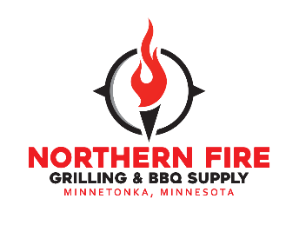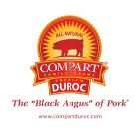

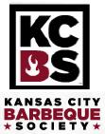

**DOUBLE - KCBS BACKYARD SERIES BBQ COMPETITION**

**June 11-13, 2021**

**Neshonoc Lakeside Camp - Resort**

**N5334 Neshonoc Road, West Salem WI 54669**

|  |  |  |
| --- | --- | --- |
| ***Entry Form***  **Team Name: KCBS#:** | | |
| **Chief Cook:** | | |
| **Address:** | | |
| **City:** | **State:** | **Zip:** |
| **Phone: ( )** | **Email:** | |
| **List Team Members:** | | |
| **Estimated day and time for arrival: Campsite #:** | | |

**PLEASE PROVIDE W-9 FORM**

**Entry Fees:**

|  |  |
| --- | --- |
| **KCBS Master Series - Day 1 – Saturday - $150.00** | $ |
| **- Day 2 – Sunday - $150.00** | $ |
| **Anything BACON Competition -** see details in guidelines – Friday - $25.00/cook | $ |
| **Kids Que – see details in guidelines –** Friday - $25 each child | $ |
|  |  |
| **T-Shirts:_**____ Sm ___ Med ___ Large ___ XL ___ 2XL **= $15 ea** | $ |
| **$18 for** ___ 3XL and ___4XL ; **Indicate P =** Purple**, C =** Charcoal Heather Gray |  |
| **Hooded Sweatshirts**:____ Sm ____ Med ____ Large ____ XL ____ 2XL **= $25 ea** | $ |
| ___ 3XL ___ 4XL **= $28 ea; Indicate P =** Purple**, C =** Charcoal Heather Gray |  |
| **Picture of T-Shirts & Sweatshirts are on last page Paid** | **$** |
| **Balance needs to be fully paid by 6/1/21 to be guaranteed a spot** | **$** |

**Do you need any special accommodations?** Yes____ No____ If yes, describe:____________________________

Please make check payable to: **Keith Tweten** Mail to: **P.O. Box 231, Holmen WI 54636-0231.**

I agree to follow the **2021 KCBS Rules and Regulations** & acknowledge the receipt & review of the**2021 KCBS Updated Emergency COVID-19 Procedures**. In consideration of my acceptance of this entry, I, the undersigned, intend to be legally bound, for myself, my teammates, heirs, executors and administrators, waive and release any and all rights and claims against the Bring’n Home the Bacon team, as well as their volunteers, officers, directors, attorneys and affiliated entities, as a result of any damages or injuries arising out of my participation in this event. I hereby grant full permission to Bring’n Home the Bacon to use any photographs, videos or other recordings of me and my team during the event for any legitimate purpose.

Team Captain/Chief Cook Date

**The 2021 BRING’N HOME THE BACON:**

* **Both competition days are part of the Minnesota Team of the Year (TOY)**
* To help with cost, teams are invited to share a campsite with another team.

**Entry Fee is $150.00** **each day** of the KCBS Backyard Series. **Please complete and send in a W-9 form along with your registration and money.** Prize money will not be given to a winning team if team has not turned in a completed and signed/dated W-9 form.

**Turn-In Times: Saturday – chicken turn-in will be at 2:30 pm and ribs at 3:00 pm. Sunday - turn-in time for chicken will be at 11:00 am and ribs at 11:30 am.**

**Prizes**

Each backyard team is required to cook both chicken and pork ribs to win the Grand Champion and the Reserve Grand Champion Awards. Prize money will be awarded as follows:



**Awards** will be presented on or close to 4:00-4:30 pm on Saturday and Sunday time may be as early as 3:00 or 3:15 pm.

**KCBS Rules Apply**

All teams must follow the 2021 KCBS Backyard Official Rules and Regulations Judging Procedure and the **2021 KCBS Updated Emergency COVID-19 Procedures**, except turn-in times. **Turn-in times are at 2:30 pm (chicken) and 3:00 pm (pork ribs) on Saturday and Sunday at 11:00 am and 11:30 am so all teams can leave earlier on Sunday; awards would be around 3 pm.**

**Cooks’ Meeting**. The cooks’ mandatory meeting for backyard and master series teams is on Friday, June 11th at 4:15 pm and if a backyard team cannot make the meeting on Friday, there will be a cooks’ meeting on Saturday, June 12th at 8:30 am next to or in the tent. If a team cannot make the meeting, they need to connect with the Reps on late Friday or Saturday.

**If a team is cooking both days,** team will receive all 2-4 numbered Styrofoam boxes on Friday or Saturday, depending on when team arrives at the campground.

**Meat Inspection.** You will need to follow the 2021 KCBS Backyard Official Rules and Regulations Judging Procedures. Meat inspection will start on Friday morning for the Saturday backyard competition, and Saturday morning meat inspection will be done for the Sunday competition (if you are competing on Sunday). If you are not able to be at the campground on Friday, meat inspection will take place on Saturday morning from 6 – 8 am. No meats shall be marinated, brined, or injected prior to meat inspection; you can trim the meats only. Also, review KCBS COVID-19 Rules and Regulations.

**Optional Competitions:**

* **Anything BACON** competition is on Friday (6/11) **– Anything BACON is sponsored by Compart Family Farms.** Each cook who competes in the Anything Bacon will receive 1 pound of thick cut Compart Duroc Bacon to be used for the competition.
* Cook must provide enough for 6 judges; can be put in a numbered Styrofoam container from KCBS Rep, or number cut and taped on a platter with 6 individual plates/bowls, etc. Payout: $150 – 1st, $100 – 2nd, and $50 for 3rd place.
* One entry per cook.
* **Organizer’s Choice** – if a cook wishes to include their entry in the Anything BACON Organizer’s Choice, cooks need to provide enough samples for 3 judges and handed separately to the KCBS Rep or Rep’s helper at the turn-in table; must have the number given by KCBS rep on the Styrofoam box or cut and taped number on a platter with the 3 individual plates/bowls. Payout $50.
* Turn-in time for Anything BACON is Friday at 7 pm; time may change; will announce at cooks’ meeting; awards at 8 pm along with the Kids Que competitors.
* **Kids Q Competition** (Friday – 6/11)– Please see separate entry form and guidelines for the Kids Que.

**Cooking/Camping Sites.**

* **Neshonoc Lakeside Camp/Resort at 608-786-1792**. Resort requests all teams to contact organizers first before contacting resort to reserve a campsite. For map of campground and fun activities, go to rvonthego.com
* Resort has two pump stations
* **Hotels (Sponsors for BHTB):** Microtel Inn (Onalaska) 608-783-0833 &/or the newly built Holiday Inn Express & Suites (Onalaska/La Crosse ) 608-667-3030; blocked rooms under Bring’n Home the Bacon.
* Campsite fees are separate from competition fees.
* If you wish to rent a golf cart – please contact Neshonoc Lakeside Camp/Resort.
* Teams may come to the campground and set up as early in the week as they wish. **If team plans on coming Friday after 9 pm or early Saturday morning, please let the organizer know your estimated time/day of arrival on the entry form.**
* **A free 20’ x 20’ spot** for teams coming in only on Saturday who do not plan on staying the whole day. We cannot promise electricity, but teams will have to carry water from building or someone’s campsite; we are happy to work with you. If lack of electricity, you can share part of a campsite with another team (if on list)
* Chief Cook takes responsibility for team conduct and to keep cooking site clean during and after the contest.
* Pits, cookers, campers, tents and other equipment shall not exceed the assigned camping site.
* **A fire extinguisher must be near all cooking devices.**
* Bring your own extension cords, connection hoses, and electrical adapters.
* Security will be available for the entire area provided by the Neshonoc Lakeside Camp – Resort.
* **Quiet times are from 11 pm to 7 am** per the Manager of Neshonoc Resort.

**Water & Electricity.**  Water, 30 and 50 amp, and 110v outlets are provided on all campsites.

**Ice.** Ice will be available at the Neshonoc Lakeside Camp-Resort.

**Restrooms & Showers.** There are 2 sets of restrooms, showers and laundry buildings in the camping area. We will have a few port-a-potties stationed around campground.

**Trash/Hot Ash/Grease**

Our team and the Neshonoc Lakeside Camp-Resort staff will be coming around your site periodically to pick up your trash. Hot coals can be placed in your firepit. There will be grease containers throughout the sites.

**Contact Information**

Laurie/Keith Tweten – Event Coordinators/Organizers - (608) 769-7446

Bunny & Rich Tuttle – KCBS Representatives – (816) 560-5308

Debbie Gage – KCBS Representative

Thank you for coming to Bring’n Home the Bacon BBQ Competition! BEST OF LUCK!

**LOGOS that will be used**

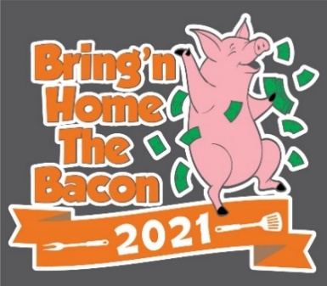

**America – Premium Hooded Sweatshirt – #8824 – 10 oz heaving weight**

**Sm – 2XL = $25.00 each – Purple and/or Charcoal Heather Grey**

**3XL & 4XL = $28.00 each – Purple and/or Charcoal Heather Grey**

**No sponsors on back of hooded sweatshirts**

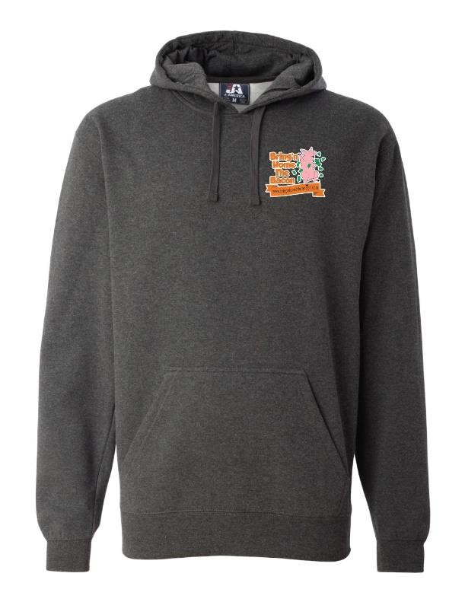

**Gildan DryBlend T-Shirts 8000**

**Small – 2XL = $15.00 – Purple and/or Charcoal Heather Grey**

**3XL & 4XL = $18.00 – Purple and/or Charcoal Heather Grey**

**Sponsors will be listed on back of t-shirt**

